**Άσκηση 1**

Τα ε-closures για κάθε κόμβο του NFA είναι:

• ε-closure({1}) = {1, 2, 5, 6, 7}

• ε-closure({2}) = {2}

• ε-closure({3}) = {3}

• ε-closure({4}) = {4}

• ε-closure({5}) = {5, 6, 7}

• ε-closure({6}) = {6}

• ε-closure({7}) = {7}

• ε-closure({8}) = {1, 2, 5, 6, 7, 8}

**Άσκηση 2**

1. Το aac αναγνωρίζεται με την ακολουθία μεταβάσεων:

1 → 5 → 6 → 8 → 1 → 2 → 3 → 4

2. Το baac αναγνωρίζεται με την ακολουθία μεταβάσεων:

1 → 5 → 7 → 8 → 1 → 5 → 6 → 8 → 1 → 2 → 3 → 4

3. Το aaca δεν αναγνωρίζεται γιατί εάν ακολουθήσουμε τα βήματα:

1 → 5 → 6 → 8 → 1 → 2 → 3 → 4

το ‘a’ στο τέλος δεν αναγνωρίζεται.

4. Το ababc δεν αναγνωρίζεται γιατί εάν ακολουθήσουμε τα βήματα:

1 → 5 → 6 → 8 → 1 → 5 → 7 → 8 → 1 → 2 → 3 → 4

το ‘b’ στο τέλος (πρίν το ‘c’) δεν αναγνωρίζεται.

**Άσκηση 3**

ε-closure({1}) = {1, 3} (Κατάσταση Α)

Temp1 = move(A, a) = {}

ε-closure(Temp1) = {}

Temp2 = move(A, b) = {2, 3}

ε-closure(Temp2) = {2, 3} (Κατάσταση B)

Temp3 = move(B, a) = {1, 3}

ε-closure(Temp3) = {1, 3} (Κατάσταση Α)

Temp4 = move(B, b) = {3}

ε-closure(Temp4) = {3} (Κατάσταση C)

Temp5 = move(C, a) = {1}

ε-closure(Temp5) = {1, 3} (Κατάσταση Α)

Temp6 = move(C, b) = {}

ε-closure(Temp6) = {}

|  |  |  |  |
| --- | --- | --- | --- |
| NFA State | DFA State | a | b |
| {1, 3} | A | - | B |
| {2, 3} | B | A | C |
| {3} | C | A | - |

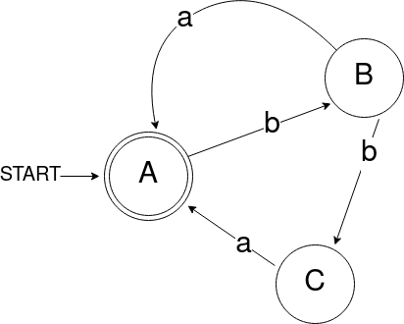

**Άσκηση 4**

1. b*|ab

NFA:

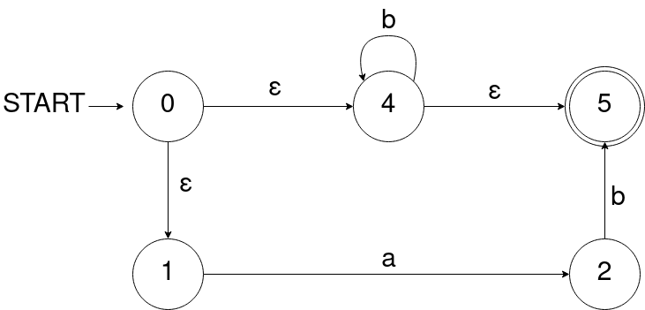

DFA:

ε-closure({0}) = {0, 1, 4} (Κατάσταση Α)

Temp1 = move(A, a) = {2}

ε-closure(Temp1) = {2} (Κατάσταση B)

Temp2 = move(A, b) = {4}

ε-closure(Temp2) = {4, 5} (Κατάσταση C)

Temp3 = move(B, a) = {}

ε-closure(Temp3) = {}

Temp4 = move(B, b) = {5}

ε-closure(Temp4) = {5} (Κατάσταση D)

Temp5 = move(C, a) = {}

ε-closure(Temp5) = {}

Temp6 = move(C, b) = {4}

ε-closure(Temp6) = {4, 5} (Κατάσταση B)

Temp7 = move(D, a) = {}

ε-closure(Temp7) = {}

Temp8 = move(D, b) = {}

ε-closure(Temp8) = {}

|  |  |  |  |
| --- | --- | --- | --- |
| NFA State | DFA State | a | b |
| {0, 1, 4} | A | B | C |
| {2} | B | - | D |
| {4, 5} | C | - | C |
| {5} | D | - | - |

2. (a|b)*

NFA:

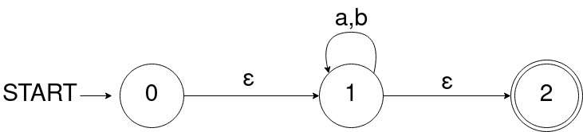

DFA:

ε-closure({0}) = {0, 1, 2} (Κατάσταση Α)

Temp1 = move(A, a) = {1}

ε-closure(Temp1) = {1, 2} (Κατάσταση B)

Temp2 = move(A, b) = {1}

ε-closure(Temp2) = {1, 2} (Κατάσταση B)

Temp3 = move(B, a) = {2}

ε-closure(Temp3) = {2} (Κατάσταση C)

Temp4 = move(B, b) = {2}

ε-closure(Temp4) = {2} (Κατάσταση C)

Temp5 = move(C, a) = {}

ε-closure(Temp5) = {}

Temp6 = move(C, b) = {}

ε-closure(Temp6) = {}

|  |  |  |  |
| --- | --- | --- | --- |
| NFA State | DFA State | a | b |
| {0, 1, 2} | A | B | B |
| {1, 2} | B | C | C |
| {2} | C | - | - |

**Άσκηση 5**

Κανονική έκφραση: (0(0|1)*0)|(1(0|1)*1)

NFA:

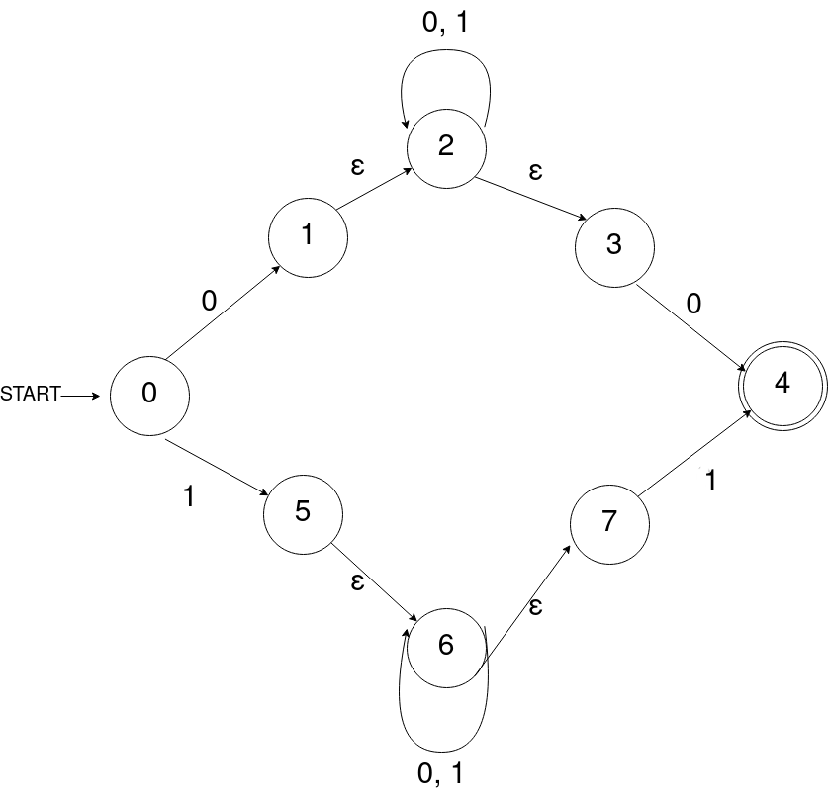

DFA:

ε-closure({0}) = {0} (Κατάσταση Α)

Temp1 = move(A, 0) = {1}

ε-closure(Temp1) = {1, 2, 3} (Κατάσταση B)

Temp2 = move(A, 1) = {5}

ε-closure(Temp2) = {5, 6, 7} (Κατάσταση C)

Temp3 = move(B, 0) = {2, 4}

ε-closure(Temp3) = {2, 3, 4} (Κατάσταση D)

Temp4 = move(B, 1) = {2}

ε-closure(Temp4) = {2, 3} (Κατάσταση E)

Temp5 = move(C, 0) = {6}

ε-closure(Temp5) = {6, 7} (Κατάσταση F)

Temp6 = move(C, 1) = {6, 4}

ε-closure(Temp6) = {6, 7, 4} (Κατάσταση G)

Temp7 = move(D, 0) = {2, 4}

ε-closure(Temp7) = {2, 3, 4} (Κατάσταση D)

Temp8 = move(D, 1) = {2}

ε-closure(Temp8) = {2, 3} (Κατάσταση E)

Temp9 = move(E, 0) = {2, 4}

ε-closure(Temp9) = {2, 3, 4} (Κατάσταση D)

Temp10 = move(E, 1) = {2}

ε-closure(Temp10) = {2, 3} (Κατάσταση E)

Temp11 = move(F, 0) = {6}

ε-closure(Temp11) = {6, 7} (Κατάσταση F)

Temp12 = move(F, 1) = {6, 4}

ε-closure(Temp12) = {6, 7, 4} (Κατάσταση G)

Temp13 = move(G, 0) = {6}

ε-closure(Temp13) = {6, 7} (Κατάσταση F)

Temp14 = move(G, 1) = {6, 4}

ε-closure(Temp14) = {6, 7, 4} (Κατάσταση G)

|  |  |  |  |
| --- | --- | --- | --- |
| NFA State | DFA State | 0 | 1 |
| {0} | A | B | C |
| {1, 2, 3} | B | D | E |
| {5, 6, 7} | C | F | G |
| {2, 3, 4} | D | D | E |
| {2, 3} | E | D | E |
| {6, 7} | F | F | G |
| {6, 7, 4} | G | F | G |

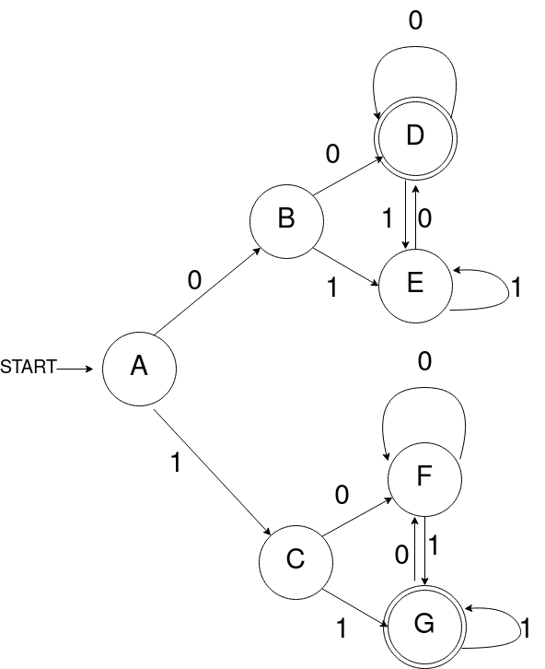

**Άσκηση 6**

Κανονική έκφραση: (a*ba*ba*)*

NFA:

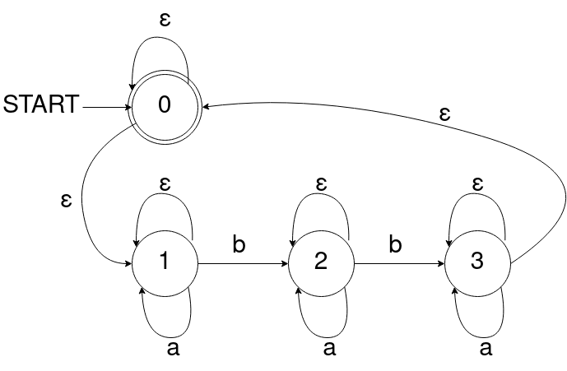

DFA:

ε-closure({0}) = {0, 1} (Κατάσταση Α)

Temp1 = move(A, a) = {1}

ε-closure(Temp1) = {1} (Κατάσταση B)

Temp2 = move(A, b) = {2}

ε-closure(Temp2) = {2} (Κατάσταση C)

Temp3 = move(B, a) = {1}

ε-closure(Temp3) = {1} (Κατάσταση B)

Temp4 = move(B, b) = {2}

ε-closure(Temp4) = {2} (Κατάσταση C)

Temp5 = move(C, a) = {2}

ε-closure(Temp5) = {2} (Κατάσταση C)

Temp6 = move(C, b) = {3}

ε-closure(Temp6) = {3, 0} (Κατάσταση D)

Temp7 = move(D, a) = {3}

ε-closure(Temp7) = {3, 0} (Κατάσταση D)

Temp8 = move(D, b) = {}

ε-closure(Temp8) = {}

|  |  |  |  |
| --- | --- | --- | --- |
| NFA State | DFA State | a | b |
| {0, 1} | A | B | C |
| {1} | B | B | C |
| {2} | C | C | D |
| {3, 0} | D | D | - |

